# Project Unit – Evidence

## **David Ellis**

## **Cohort E18**

## P1 – Group Project – GitHub Contributors Page Screenshot *W14

Take a screenshot of the contributor’s page on Github from your group project to show the team you worked with.

## P2 – Group Project – Project Brief Screenshots *W14

Take a screenshot of the project brief from your group project.

## P3 – Group Project – Planning Screenshots *W14

Provide a screenshot of the planning you completed during your group project, e.g. Trello MOSCOW board.

## P4 – Acceptance Criteria and Test Plan *W14

Write an acceptance criteria and test plan.

## P5 – User Sitemap *W5

Create a user sitemap

## P6 – Wireframe Diagrams *W5

Produce two wireframe designs

## P7 – System Interaction Diagrams( 2) *W14

Produce two system interaction diagrams (sequence and/or collaboration diagrams).

## P8 – Object Diagrams (2) *W14

Produce two object diagrams.

## P9 – Algorithm Example Screenshots and Explanations*W14

Select two algorithms you have written (NOT the group project). Take a screenshot of each and write a short statement on why you have chosen to use those algorithms.

## P10 – Pseudocode Example Screenshot

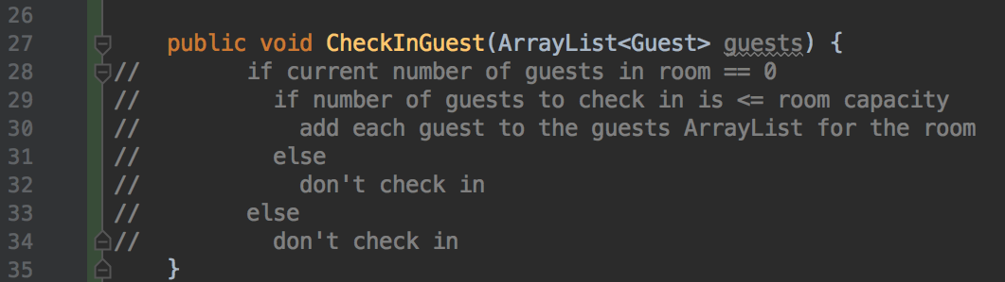

## P11 – Individual Project Screenshot and GitHub Link

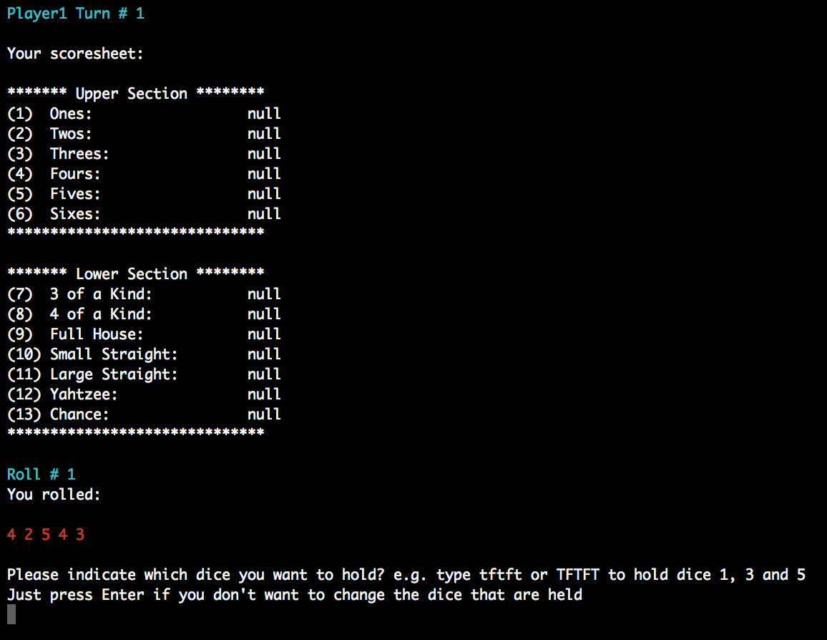

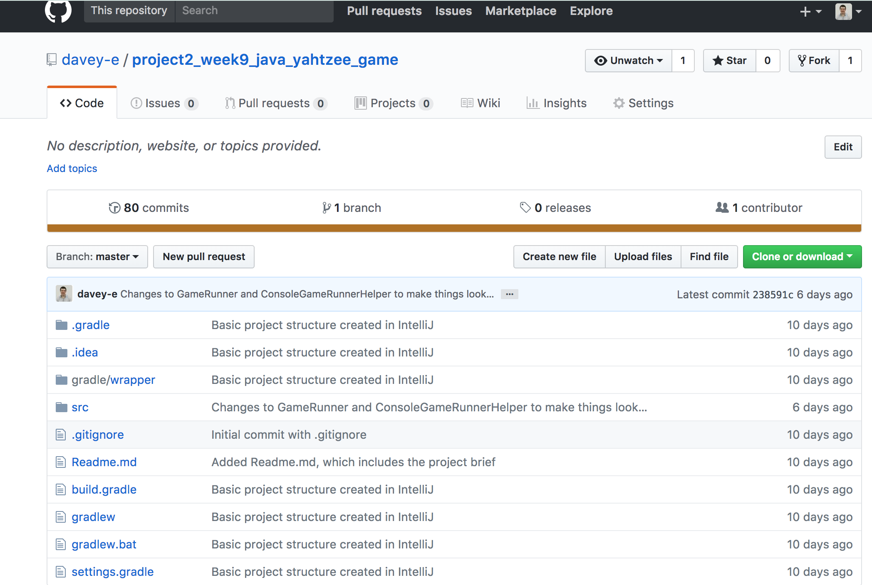

<https://github.com/davey-e/project2_week9_java_yahtzee_game>

## P12 – Project Planning Screenshots/Photos at Different Stages *W9

Take screenshots or photos of your planning and the different stages of development to show changes.

## P13 – User Input Processing Screenshots *W5

Show user input being processed according to design requirements. Take a screenshot of:

●  The user inputting something into your program

●  The user input being saved or used in some way

## P14 – Data Interaction and Persistence Screenshots *W5

Show an interaction with data persistence. Take a screenshot of:

●  Data being inputted into your program

●  Confirmation of the data being saved

## P15 – User Feedback/Output Screenshots *W5

Show the correct output of results and feedback to user. Take a screenshot of:

●  The user requesting information or an action to be performed

●  The user request being processed correctly and demonstrated in the program

## P16 – API Usage Screenshots *W12

Show an API being used within your program. Take a screenshot of:

●  The code that uses or implements the API

●  The API being used by the program whilst running

## P17 – Bug Tracking Report *W14

Produce a bug tracking report

## P18 – Testing Example Screenshots *W11

Demonstrate testing in your program . Take screenshots of:

●  Example of test code

●  The test code failing to pass

●  Example of the test code once errors have been corrected

●  The test code passing